1. **Agenda**: (All in Theory but in next lecture with code)
   1. How to use JDBC Template from Spring JDBC Framework.
   2. What methods are available inside this.
   3. How to perform Query.
2. 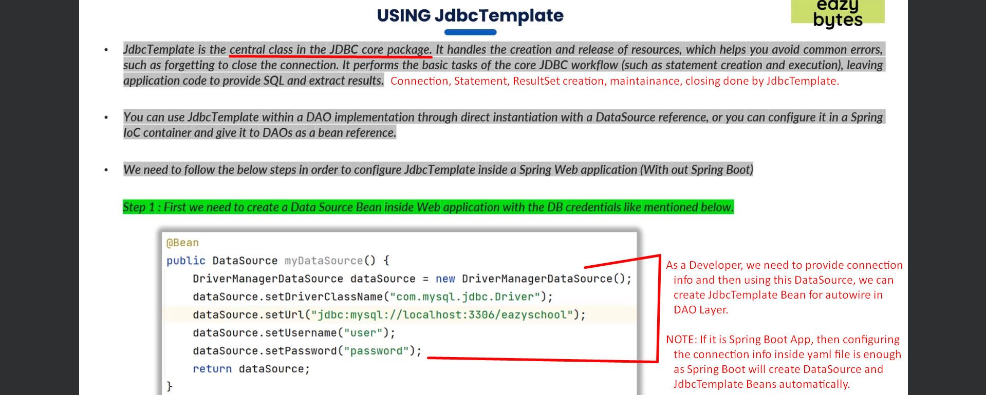  
     
   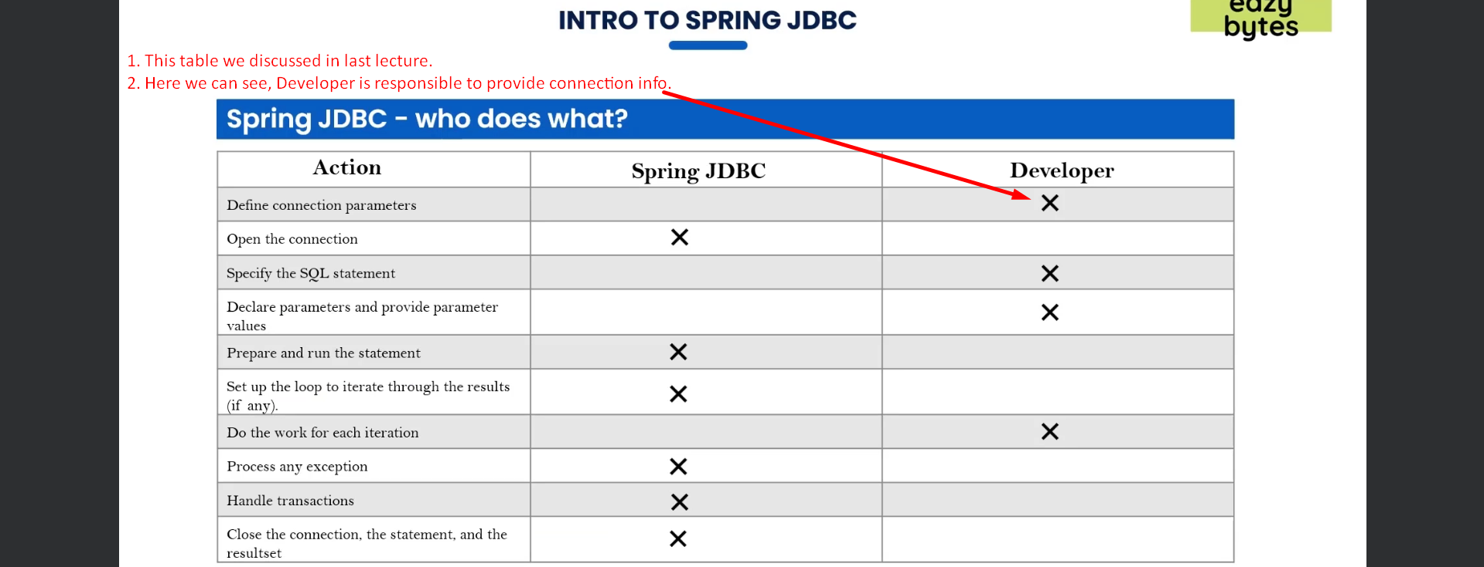
3. JdbcTempalate Bean.  
   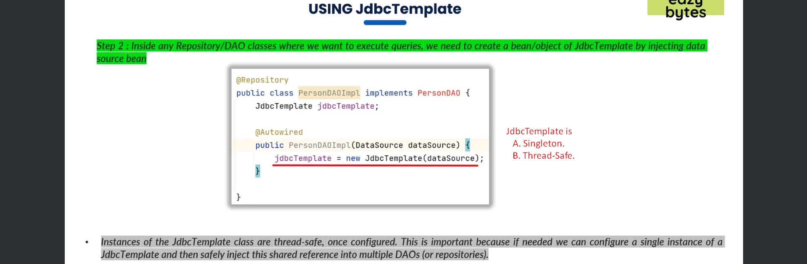
4. SELECT Query Examples:  
   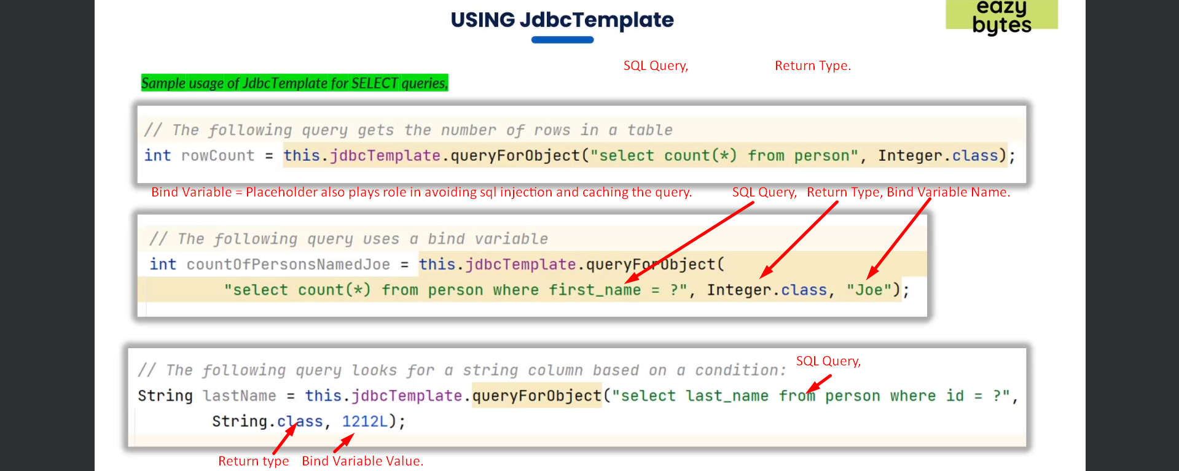
5. Insert, Update, Delete  
   